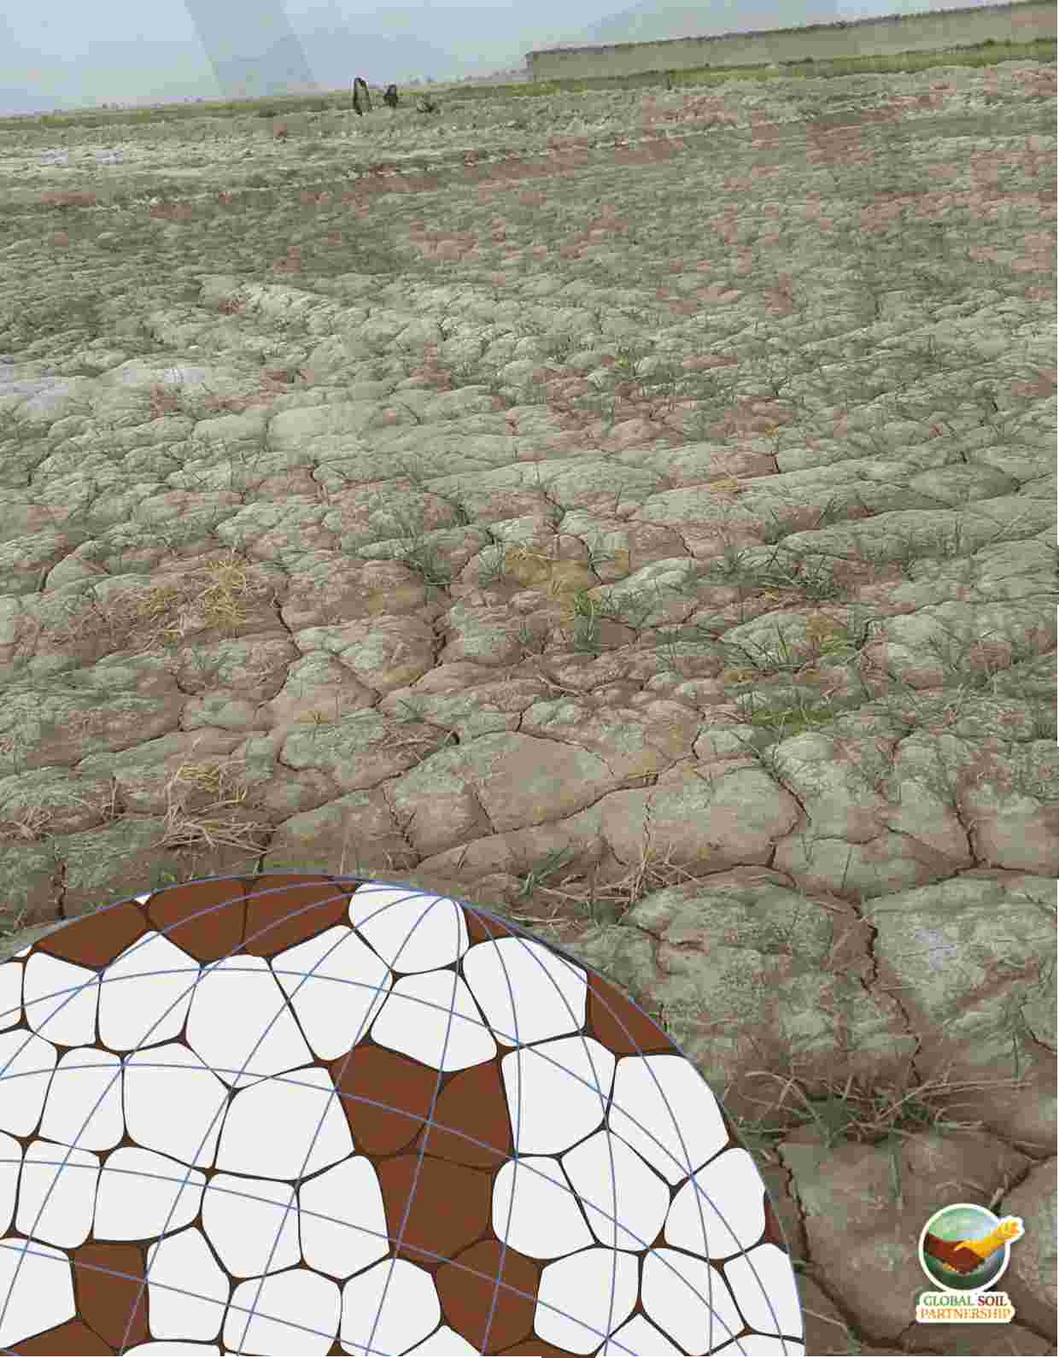

Food and Agriculture



Organization of the

United Nations



**Global Soil Salinity Map**

**(GSS map)**

**Lesson 2: Software installation and data organization**

Global Soil Salinity Map (GSS map) - Capacity building for national assessment of salt-affected soils: Lesson 2 – Software installation and data organization

Capacity building program is part of the country-driven framework for updating national and global level information of salt-affected soils. It aims at mobilizing country-level resources and expertise to assess the status of salt-affected soils and build foundation for future monitoring and management of these soils. The program is a systematic procedure to strengthen national capacities as well as harmonize global approaches for building information of salt-affected soils. This document illustrates the second Lesson of the capacity-building program and focuses on the software installation and database organization.

FOOD AND AGRICULTURE ORGANIZATION OF THE UNITED NATIONS ROME, 2020

Disclaimer and copyright

**Recommended citation:**

Omuto, C.T., Vargas, R., Viatkin, K., Yigini, Y., 2020. Global Soil Salinity Map (GSS map), Lesson 2 –

Software installation and data organization. Rome

The designations employed and the presentation of material in this information product do not imply the expression of any opinion whatsoever on the part of the Food and Agriculture Organization of the United Nations (FAO) concerning the legal or development status of any country, territory, city or area or of its authorities, or concerning the delimitation of its frontiers or boundaries. The mention of specific companies or products of manufacturers, whether or not these have been patented, does not imply that these have been endorsed or recommended by FAO in preference to others of a similar nature that are not mentioned.

The views expressed in this information product are those of the author(s) and do not necessarily reflect the views or policies of FAO.

Summary

This Lesson is the second step of the capacity-building program, which is designed to build national capacities as well as harmonize procedures for developing information of salt-affected soils at the national and global levels. The overall goal of this Lesion is to support participants in software installation and using the software to organize input data for assessing salt-affected soils at the national level. At the end of the lesson, the participants are expected to have installed software and organized database for mapping salt-affected soils in their countries.

Summary outputs for organizing input national information for assessing salt-affected soils

**Item Description Timeline**

**Installed software for database organization**

**Software**

**Data**

Spreadsheet software MS Excel

GIS database software QGIS and SAGA Data harmonization software ILWIS and R

**Organized input data**

Soil indicators of salt problems EC, ESP, pH

Boundary shapefile

One week

GIS layers

Spatial layers

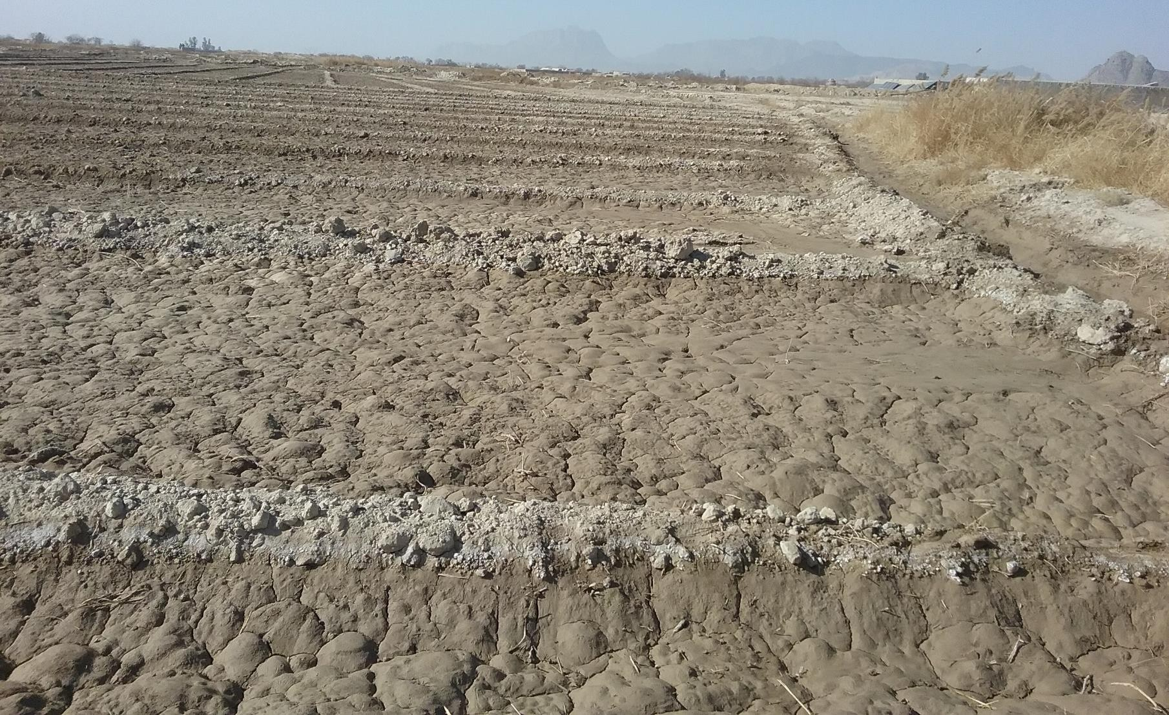

Table of Contents

Disclaimer and copyright ......................................................................................................................... i Summary ................................................................................................................................................. ii List of Figures ......................................................................................................................................... iii

1 Introduction .................................................................................................................................... 1

1.1 Overview ................................................................................................................................. 1

1.2 Objective ................................................................................................................................. 1

1.3 Expected outcomes................................................................................................................. 1

2 GIS database for assessing salt-affected soils................................................................................. 1

2.1 Software for GIS database organization ................................................................................. 1

2.1.1 Applications in QGIS........................................................................................................ 1

3 Resources ........................................................................................................................................ 2

4 Activities.......................................................................................................................................... 2

4.1 Software installation ............................................................................................................... 2

4.1.1 Installing QGIS ................................................................................................................. 2

4.1.2 Installing ILWIS ................................................................................................................ 2

4.1.3 Installing R ....................................................................................................................... 3

4.1.4 Installing RStudio ............................................................................................................ 3

4.1.5 Installing R package......................................................................................................... 3

4.2 Database organization ............................................................................................................ 4

4.2.1 Organizing spreadsheet data .......................................................................................... 4

4.2.2 Organizing GIS data ......................................................................................................... 5

5 Outputs ........................................................................................................................................... 9

List of Figures

Figure 4.1: Input spreadsheet data format............................................................................................. 5

Figure 4.2: Reprojecting GIS layers in QGIS ............................................................................................ 6

Figure 4.3: Steps for vector-to-raster conversion in QGIS ...................................................................... 7

Figure 4.4: Image processing using semi-automatic classification plugin .............................................. 8

Figure 5.9: Steps for digital terrain analysis in SAGA .............................................................................. 8

Figure 4.6: Creating spatially harmonized GIS database in ILWIS .......................................................... 9

1 Introduction

1.1 Overview

Proper data organization is an important pedometrics step in digital soil mapping and more so in identification of the true extent of salt-affected soils. Most soil profile data collection are organized in varying soil-depth steps and irregular soilscape patterns. Adequate understanding and modelling of soil variations are enhanced with well-organized input database. Furthermore, properly organized data minimizes syntax errors at the data analysis stage. The focus of this Lesson is to facilitate participants in harmonized organization of input database for assessing salt-affected soils. The input database to be organized was developed during Lesson one of the Capacity Building program. This Lesson, therefore, requires outputs from Lesson one. The Lesson is intended for participants who have completed Lesson one or participants with complete database for mapping salt-affected soils. Its output is a spatially compatible GIS database for national assessment of salt problems.

1.2 Objective

The overall objective of this Lesson is to establish a spatially compatible GIS database for national assessment of salt-affected soils in each member country.

1.3 Expected outcomes

By the end of this Lesson, the participants are expected to:

i. Install and operationalize GIS database software for mapping salt-affected soils

ii. Spatially harmonize input data into a GIS database for mapping salt-affected soils

2 GIS database for assessing salt-affected soils

2.1 Software for GIS database organization

Software is part of the tools and methods for digital soil mapping framework. The following software were downloaded during Lesson one: QGIS, ILWIS, and R. This section discusses some other potential applications of these software in database organization.

2.1.1 Applications in QGIS

QGIS is a versatile and relatively fast software with many GIS functionalities such as GIS database development and organization, GIS operations (layer trimming, projections, format conversion, views, etc.), remote sensing applications (such as image download, correction, pre-processing, classification, band analysis, etc.), map layouts, among others. Its documentation and tutorials for beginners are freely downloadable at [https://qgis.org/en/site/forusers/download.html (a](https://qgis.org/en/site/forusers/download.html)ccessed on 30th October

2019). The software also has a rich contribution of freely downloadable add-on packages known as plugins and a vibrant user-support (for example, through [https://gis.stackexchange.com/)](https://gis.stackexchange.com/).

QGIS has a Graphical User Interface (GUI) for easy access to its functions. The e functions are easily accessible through panels or shortcut icons by simple clicks/selection. In addition,

3 Resources

The following resources are useful for implementing the activities during data organization

(a) Software (QGIS, ILWIS, Spreadsheet software) (b) Own dataset (soil profile and GIS layers)

(c) Lecture materials

4 Activities

4.1 Software installation

4.1.1 Installing QGIS

Step 1: Go to the site [https://qgis.org/en/site/forusers/download.html a](https://qgis.org/en/site/forusers/download.html)nd download the latest release depending on the computer OS. For example, for Windows 64 bit, download QGIS Standalone Installer Version 3.10 (64 bit).

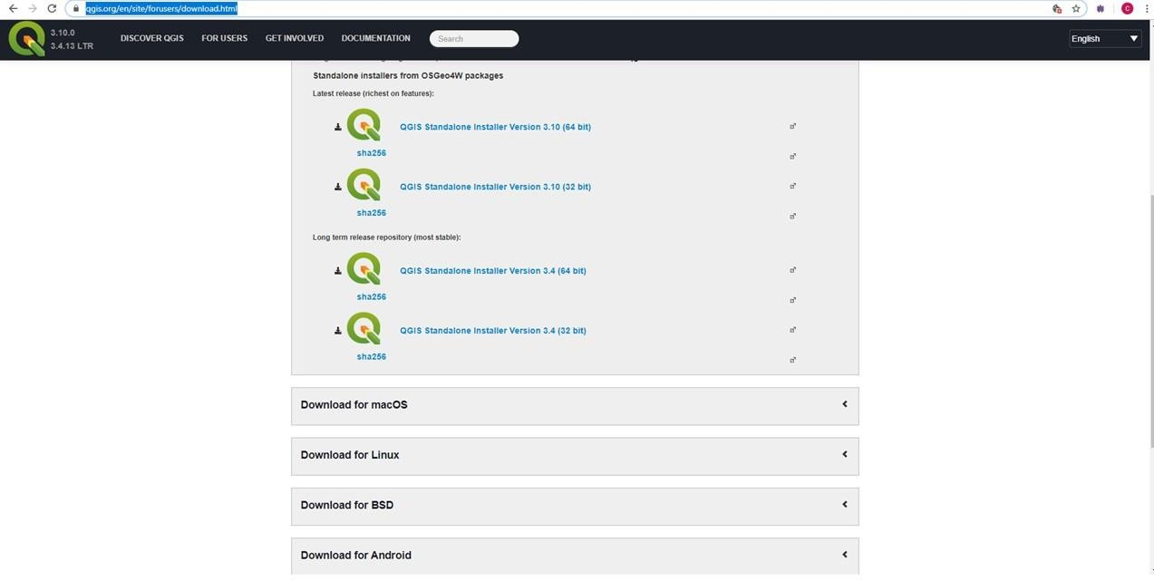

Step 2: Launch the installer

Step 3: The software (QGIS Desktop with GRASS) is available in a QGIS folder

4.1.2 Installing ILWIS

Step 1: Go to the site [https://www.itc.nl/ilwis/download/ilwis33/ a](https://www.itc.nl/ilwis/download/ilwis33/)nd download

ILWIS3.3Academic.exe (19.3 MB) and ILWIS 3.31 Update (for ILWIS 3.3 only)

Step 2) Install ILWIS3.3Academic.exe (19.3 MB) first and do not start the software yet.

Step 3) Install ILWIS 3.31 Update (for ILWIS 3.3 only). During installation, it will request to locate ILWIS

3.3. Navigate to C:\Program Files (x86)\ILWIS 3.3 Academic and scroll down to choose the blue colored file Ilwis30.exe. Complete the installation

Step 4) Launch the software (whose icon should now be on the desktop).

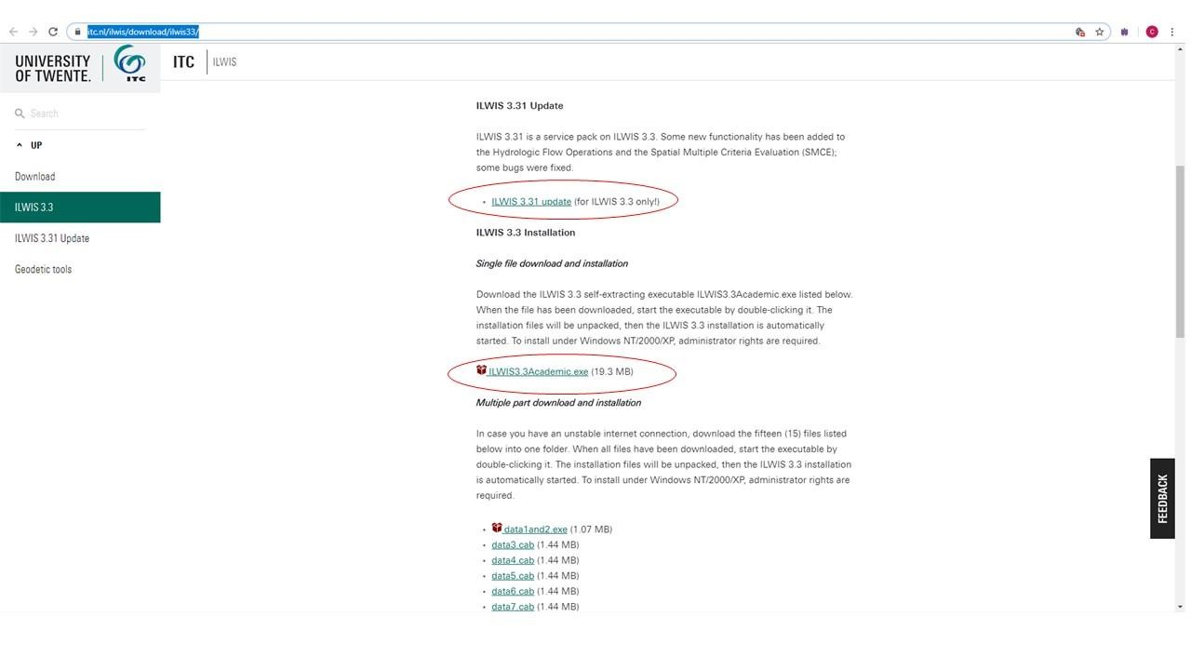

4.1.3 Installing R

Step 1: Go to the site [https://cran.r-project.org/ a](https://cran.r-project.org/)nd download the installer suitable for your operating system. For Windows, choosing Download R for Windows takes you to another site from which you choose  *Install R for the first time*. Another window for download opens.

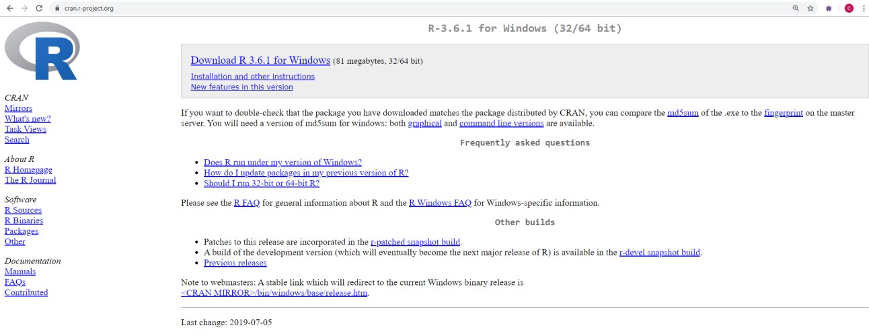

Step 2: Install the window installer, choose the language (preferably English), bit rate for your computer, and choose *No (Accept default)* for the start-up options.

4.1.4 Installing RStudio

Step 1: Go to the site [https://www.rstudio.com/ ,](https://www.rstudio.com/) click download Rstudio, the preferred version (like

Free RStudio Desktop) and download.

Step 2. Launch the installer and install the software

4.1.5 Installing R package

Step 1: Start RStudio and click the Packages Icon in the bottom right corner, the click *Install.* A window for install Packages pops.

Step 2: If connected to internet, type the name of the package to install (for example sp) Step 3: Click *Install* button and the package will be installed and ready for use

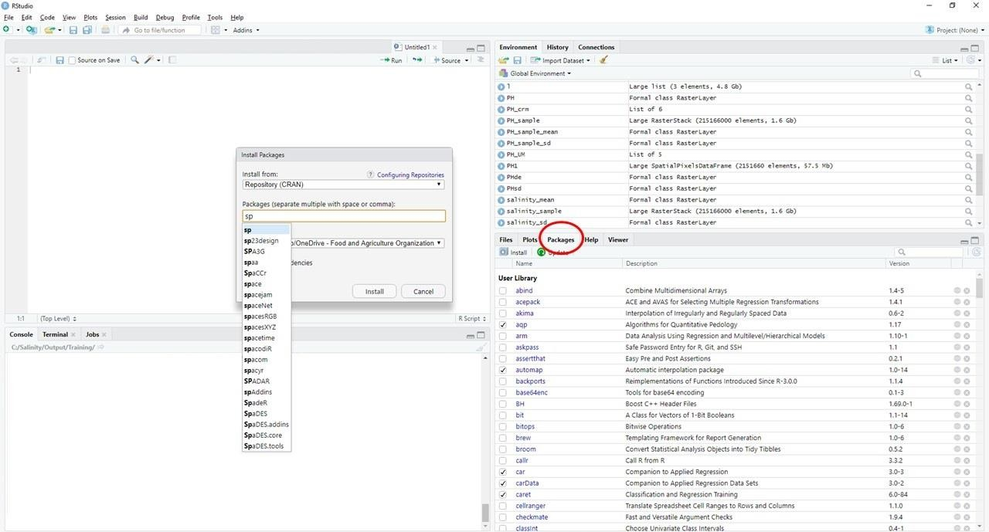

4.2 Database organization

4.2.1 Organizing spreadsheet data

Spreadsheet data should be organized to allow sequential computer scanning during data analysis.

1. Let the first column be the variable for indexing the serial order of the data.

2. Other variables in the database are consecutively ordered beginning with profile ID, Location description (if any), Latitude and Longitude, and sampling depth-range (Figure 4.1).

3. The depth-range is split into two variables: *Upper* and *Lower*. *Upper* denotes the first part of

the depth-range while *Lower* denotes the last part of the depth-range. The value of *Upper* in one sample should be the same as the value for *Lower* in the preceding sample for the same profile ID (Figure 4.1).

4. Other variables such as Depth Code (or Horizon number), soil texture components, organic

carbon, pH, EC, ESP, and additional soil properties such soluble ions (and/or exchangeable sodium ions and CEC) are also included in that order (Figure 4.1). The Depth Code (or Horizon) should have consecutive numbers beginning from one to the last sampled depth/horizon in each profile. This arrangement creates repeated numbers/codes of the profile ID and Longitude and Latitude values (Figure 4.1).

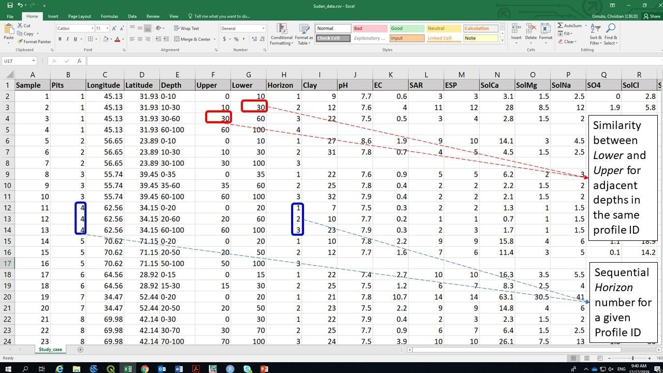

Figure 4.1: Input spreadsheet data format

It is important to ensure that:

• *Upper, Lower,* and *Horizon* of each profile ID increase down the soil profile

• *Latitude, Longitude* and *Profile ID* remain constant for each Profile ID

• *Upper* is equivalent to the first part of the *Depth* range and *Lower* is the second part of *Depth*

4.2.2 Organizing GIS data

(a) Harmonizing coordinate reference system

Harmonization of coordinate reference system (CRS) is done by Reprojection, which is the terminology often used in GIS for transforming one CRS to another. The following points need consideration when *reprojecting* GIS layers:

• Identifying the CRS to use on all GIS layers (here known as harmonized CRS)

• It is important to choose UTM projection for harmonizing all layers CRS

• CRS of each GIS layer and individual need for *reprojection* should be noted before *reprojection*

• *Reprojecting* vector layers requires specifying the CRS when the layers are saved anew

• *When reprojecting* raster layers, *source* CRS (current) and *target* CRS need to be specified

The steps for *reprojecting* vector and raster layers is given in Figure 4.2.

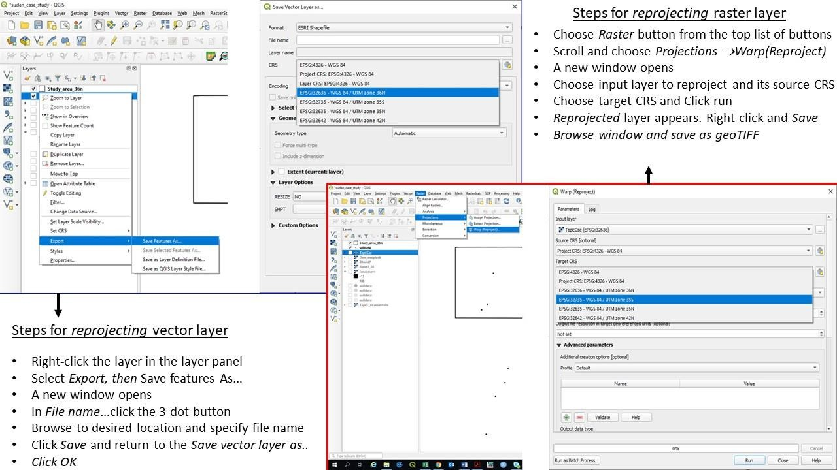

Figure 4.2: Reprojecting GIS layers in QGIS

(b) Harmonizing layer format

Not all GIS layers are available in uniform file format. Sometimes, some soil forming factors such as soil map, geology, and land cover types are only available as polygon vector files. Harmonizing GIS layer formats attempts to convert vector files to raster formats. Except for soil profile data, all GIS layers for mapping salt-affected soils need to be raster layers. Vector-to-raster conversion is a GIS operation used for harmonizing vector polygons into raster data types. Some of the pre-requisite operations before vector-to-raster harmonization include projection harmonization, identification of the target polygon attribute to use in the conversion, decision on the target pixel resolution of the final raster map, and cleaning of missing entries, topology errors, and associated errors in the data entry. Figure 4.3 illustrates the steps for vector-to-raster conversion in QGIS.

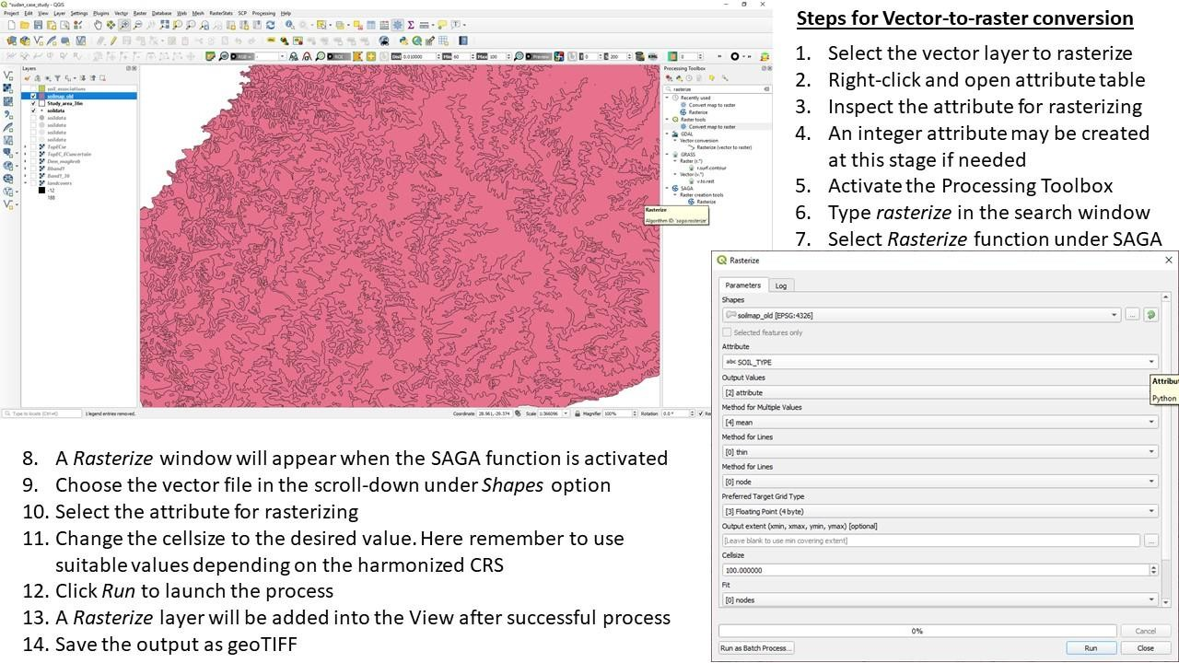

Figure 4.3: Steps for vector-to-raster conversion in QGIS

(c) Image correction

Freely downloadable remote sensing images have varied characteristics that need harmonization before application in spatial modelling of salt-affected soils. These characteristics range from differences in spatial extent, image digital numbers, image conversion models to land surface reflectance, and downloaded file format. Most downloaded images are wrapped in compressed files such as .zip, .rar or .gz. They should be unpacked into commonly used GIS file formats such as geoTIFF, ASCII, HDF, etc. Software such as WinZip or WinRar or 7-Zip unpacks the compressed files into a preferred destination folder (such as C:/Salinity/Output). Sometimes the unpacked file may still contain compressed files and another unpacking may be necessary to extract the GIS files. It is important that different zipped files are unzipped into different folders to avoid over-writing metafiles and for processing each file independently. Semi-Automatic Classification Plugin (SCP) in QGIS provides a quick way for simultaneous geometric and radiometric correction of remote sensing images. The plugin has many functions for handling different types of remote sensing images such as Landsat, Sentinel-2, Sentinel-3, ASTER, MODIS, etc. Figure 4.4 illustrates how these types of images are corrected using SAC plugin in QGIS.

(d) Digital terrain modelling

Terrain modelling focuses on determining relief parameters influencing soil formation or translation of soil salts during leaching, runoff or wind erosion. Relief parameters are primary or secondary attributes. Primary attributes are derived from the altitude and directional location of the topographic surface. They include slope, aspect, curvature, flow accumulation and up-slope flow contributing area. Secondary attributes are obtained from the altitude and derivatives of the primary attributes. They include indices such as topographic wetness index, compound topographic index, stream power index, etc. SAGA software has a module for developing 14 terrain parameters from DEM input (Figure 4.5)

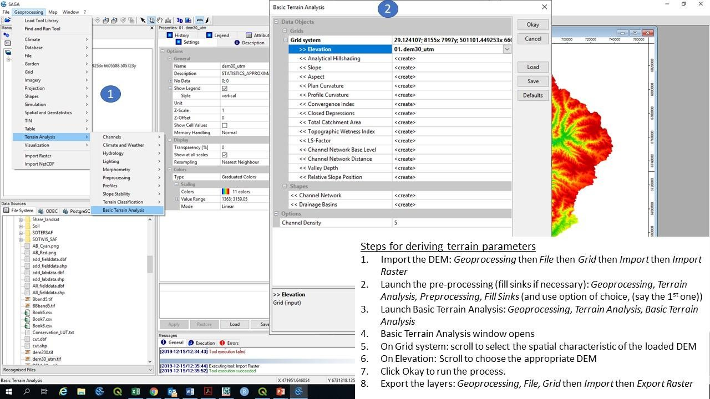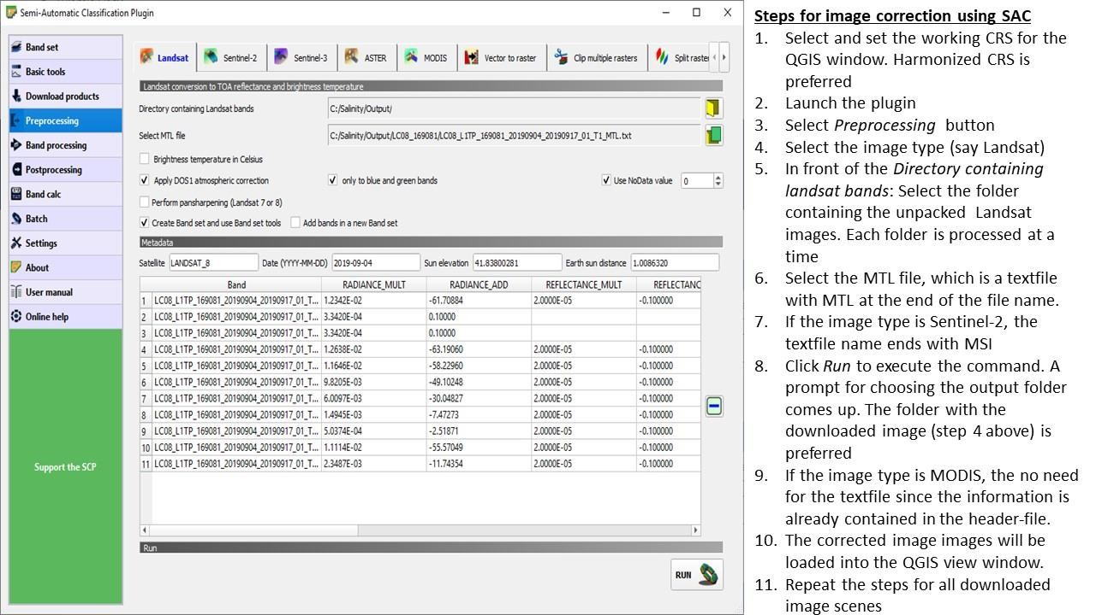

Figure 4.4: Image processing using semi-automatic classification plugin

Figure 5.9: Steps for digital terrain analysis in SAGA

(e) Final GIS database

All spatial data in the GIS database should have uniform CRS (i.e. harmonized CRS). In addition, all raster layers should have uniform pixel resolution. Uniform pixel resolution is obtained by resampling all the raster layers to the preferred spatial resolution. A map-list in ILWIS is one way of ensuring that all harmonized raster layers have uniform CRS and pixel resolution. Figure 4.6 gives the steps for creating a map-list of harmonized raster layers

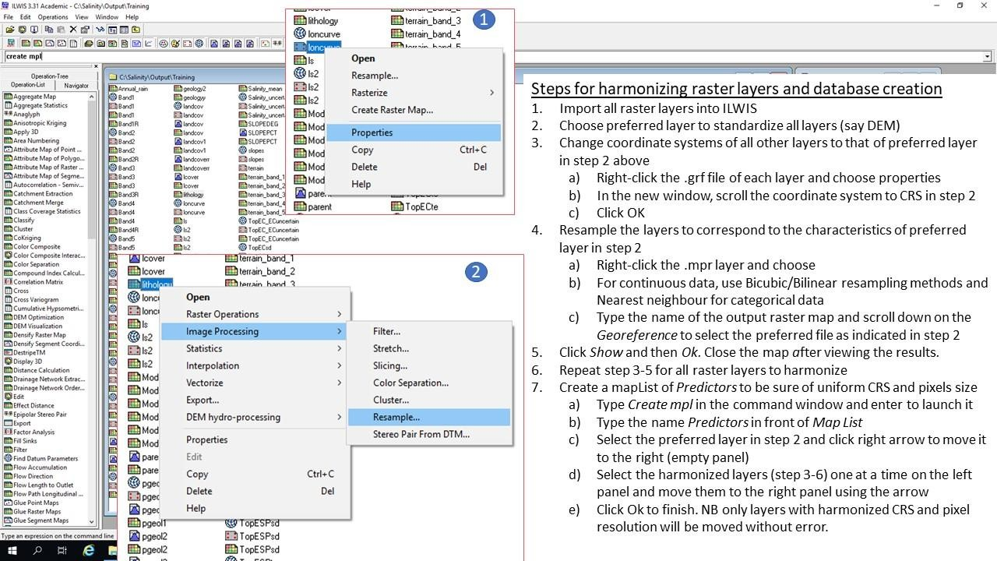

Figure 4.6: Creating spatially harmonized GIS database in ILWIS

5 Outputs

Each participant is expected to produce the following at the end of this lesson:

1. Organized database of indicators of salt-affected soils (EC, pH, ESP)

2. Organized database of GIS layers (land cover, climate, geology, images, DEM, soil map, etc.)

3. Installed computer software for mapping salt-affected soils

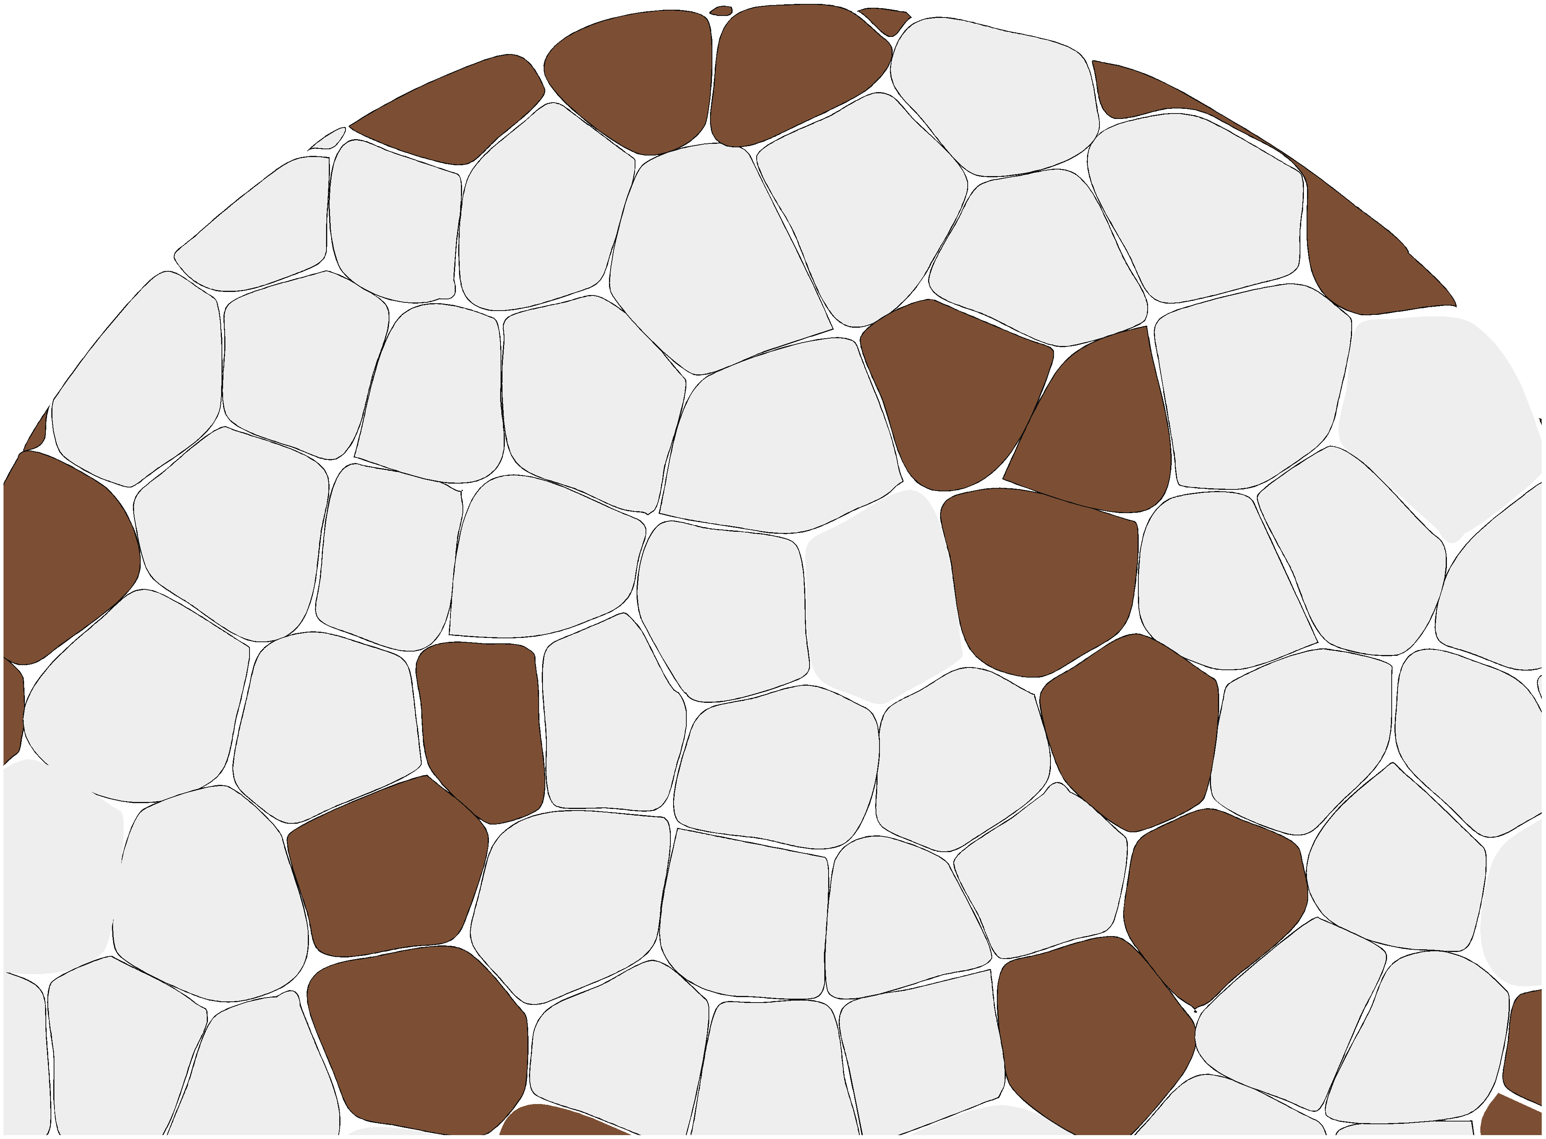

Thanks to the financial support of